**CHAPTER 1**

**INTRODUCTION**

**1.1 Introduction to NutriFit Analytics and Dashboard System**

The NutriFit Analytics and Dashboard System offers a comprehensive, AI-augmented solution for individuals seeking to transform their nutrition and fitness data into actionable health insights. Designed with a focus on interactivity, personalization, and user engagement, the platform empowers users to track, visualize, and optimize their nutritional intake and fitness progress across multiple dimensions. Built using Python and Flask, with a sleek dark-themed UI and backed by a robust database, the system leverages modern nutrition analytics techniques to support data-driven health decisions for users at every fitness level.At its core, the platform features personalized user profiles, ensuring tailored experiences based on individual health goals and dietary preferences. Users can access key nutrition metrics and explore dynamic visual reports of their consumption patterns, while the AI-powered recommendation system provides personalized suggestions to improve dietary habits. This adaptive intelligence enables individuals to proactively respond to nutritional gaps, manage their daily intake efficiently, and optimize their health strategies.The dashboard provides real-time filtering options—by date range, food categories, and nutritional components—allowing users to explore their nutritional trends through intuitive visualizations such as bar charts, time series plots, and macronutrient distribution graphs. Styled with modern UI principles and a clean dark-themed interface, the system ensures accessibility and ease of use, even when working with complex nutritional datasets.By integrating nutrition tracking, intelligent recommendations, and a user-centric design, this system offers a powerful tool for individuals to monitor their health progress, anticipate nutritional needs, and strategically navigate their personal wellness journey.

**1.2 Motivation**

The motivation behind NutriFit arises from the growing need for individuals to understand and optimize their nutritional intake more effectively in an increasingly health-conscious society. Many people struggle with fragmented nutrition tracking, static diet plans, and a lack of personalized insights, which hinders their ability to make informed decisions about their health. Traditional nutrition apps often fall short in offering dynamic, user-friendly experiences or adaptive capabilities that can guide strategic meal planning. NutriFit addresses these limitations by delivering an interactive, intelligent, and accessible platform that transforms raw nutritional data into meaningful health insights.Furthermore, as nutritional science evolves and dietary patterns become more complex, there is a pressing demand for tools that not only track past consumption but also provide guidance for future meals. By integrating advanced analytics through machine learning and offering granular tracking of macronutrients, micronutrients, and hydration, the platform empowers users to identify patterns, spot nutritional gaps, and proactively manage their dietary needs.Beyond the technical capabilities, NutriFit also promotes a health-conscious culture among its users. With personalized goal setting and progress tracking, it ensures that all types of users—from fitness enthusiasts to those with specific dietary requirements—can access the right information at the right time, fostering a consistent approach to nutrition management. This project aims to bridge the gap between nutritional data and healthy decision-making, turning everyday food choices into strategic assets that drive wellness, fitness improvement, and overall health outcomes.

**1.3 Sustainable Development Goal of the Project**

NutriFit aligns closely with the United Nations' Sustainable Development Goal 3 (SDG 3): Good Health and Well-being, by promoting healthy lifestyles and nutritional awareness through the use of advanced data analytics and intelligent recommendation technologies. It supports the development of digital health infrastructure that enables individuals—particularly those with limited access to nutritional expertise—to harness the power of data for personal health improvement and dietary optimization.By transforming raw nutrition data into accessible, actionable insights, the platform empowers users to make smarter, evidence-based decisions about their diet and health. This directly contributes to the adoption of innovative practices in personal health management and nutritional education. The inclusion of scalable, user-friendly features ensures that such health innovation is both inclusive and sustainable across different demographics.Additionally, the system contributes to SDG 12: Responsible Consumption and Production by enabling better meal planning and food waste reduction. Users can optimize their grocery shopping, minimize food waste, and align consumption with actual nutritional needs—fostering more sustainable eating patterns and resource management.Through the integration of intelligent nutrition analytics, personalized recommendations, and inclusive access to data-driven health tools, NutriFit advances sustainable development by supporting health innovation, improving individual well-being, and promoting efficient and responsible food consumption practices.

**1.4 Product Vision Statement**

**1.4.1. Audience**

* **Primary Audience**: Health-conscious individuals, fitness enthusiasts, and individuals with specific dietary goals seeking personalized nutrition tracking and insights.
* **Secondary Audience:** Nutritionists, fitness coaches, and wellness professionals who support clients in achieving their health goals.

**1.4.2. Needs**

**Primary Needs:**

* Real-time nutrition data visualization and filtering by food categories, macronutrients, and time periods.
* Personalized recommendations to optimize dietary intake and support health goals.
* User profiles to provide customized tracking and insights based on individual requirements.

**Secondary Needs:**

* Easy-to-use interface for tracking daily food intake and hydration levels.
* Automated nutritional analysis for better health decision-making.
* Scalability to accommodate diverse dietary preferences and health objectives.

**1.4.3. Products**

**Core Product:** An interactive, web-based nutrition analytics dashboard with real-time visualizations, personalized recommendations, and AI-powered insights.

**Additional Features:**

* AI-powered nutritional recommendations for healthier choices.
* Macronutrient distribution charts and calorie tracking.
* Progress visualization and goal achievement metrics.
* Water intake tracking and reminders.
* Secure login, profile management, and data privacy controls.

**1.4.4. Values**

**Core Values**:

* **Health-Driven:** Enabling informed nutritional decisions through data transparency and clarity.
* **Usability:** Delivering intuitive user experiences for individuals regardless of their nutrition knowledge.
* **Personalization:** Providing tailored insights and recommendations based on individual health goals.

**Differentiators**:

* + **Integrated Forecasting**: Utilizing machine learning models for personalized nutritional guidance.
  + **Dynamic Visualizations:** Interactive, customizable visual dashboards powered by modern web technologies.
  1. **Product Goal**

The primary goal of NutriFit is to transform the way individuals interact with and extract value from their nutrition data by offering a secure, intelligent, and user-friendly health analytics environment. By integrating advanced visualization tools and AI-powered recommendations, the platform empowers users to understand their nutritional patterns, monitor health progress, and make data-driven dietary decisions with confidence and clarity. The aim is to streamline access to personalized health insights, reduce dependence on generic diet plans, and foster a culture of nutritional awareness among users of all health backgrounds.In addition to delivering core analytics, NutriFit is designed to promote inclusivity and health transparency through personalized user profiles, allowing individuals with different goals—weight management, muscle building, or specific dietary requirements—to interact with nutrition data tailored to their needs. This personalized approach enhances user engagement, ensures relevance, and supports informed health decision-making, driving nutritional optimization and wellness efficiency.Ultimately, the product goal is to create a scalable, intelligent, and sustainable nutrition solution that helps individuals not only understand their current dietary patterns but also improve their future health outcomes through accurate tracking and personalized guidance. By blending real-time nutrition data exploration with smart recommendations, NutriFit aspires to be a cornerstone in building healthier, insight-driven individuals who are equipped to maintain optimal nutrition in their daily lives.

* 1. **Product Backlog**

**Table 1.1 Product Backlog of NutriFit Analytics and Dashboard System**

|  |  |
| --- | --- |
| **S. No** | **User Stories of NutriFit Analytics and Dashboard System** |
| #US 1 | As a health-conscious user, I want to view key nutrition metrics (total calories, macronutrients, water intake, number of meals) so that I can quickly assess my overall dietary performance without having to analyze raw data. |
| #US 2 | As a user, I want to filter nutrition data by date range, food categories, and macronutrient distribution so that I can focus on specific dietary patterns and nutritional aspects that are relevant to my health goals. |
| #US 3 | As a fitness enthusiast, I want to view nutritional distribution by macronutrients through interactive charts so that I can identify balanced or imbalanced dietary patterns and adjust my meal planning accordingly. |
| #US 4 | As a new user, I want to easily register for the dashboard with a username and password so that I can create an account and gain access to personalized nutrition analytics features. |
| #US 5 | As a user who forgot my password, I want to reset it through a secure system so that I can regain access to the dashboard without creating a new account. |
| #US 6 | As a user with specific dietary goals, I want to access advanced analytics including AI-based recommendations and nutritional forecasts so that I can make data-driven health decisions. |
| #US 7 | As a user, I want to add new food records to my daily log with proper nutritional data so that I can keep my dietary tracking up to date without compromising data accuracy. |
| #US 8 | As a user, I want to update existing food entries so that I can correct errors or adjust portion sizes as needed to maintain accurate nutritional reporting. |
| #US 9 | As a user, I want to delete food records from my log so that I can remove duplicate or erroneous entries that might skew my nutrition analytics results. |

**As the table 1.1 shows the product backlog of NutriFit Analytics and Dashboard System was** configured using the MS planner Agile Board which is represented in the following Figure 1.1. The Product Backlog consists of the complete user stories of NutriFit Analytics and Dashboard System

Each user story consists of necessary parameters like MoSCoW prioritization, Functional and non-functional parameters, detailed acceptance criteria with linked tasks.

Figure 1.1 MS Planner Board of NutriFit Analytics and Dashboard System

**1.7 Product Release Plan**

The following Figure 1.2 depicts the release plan of the project

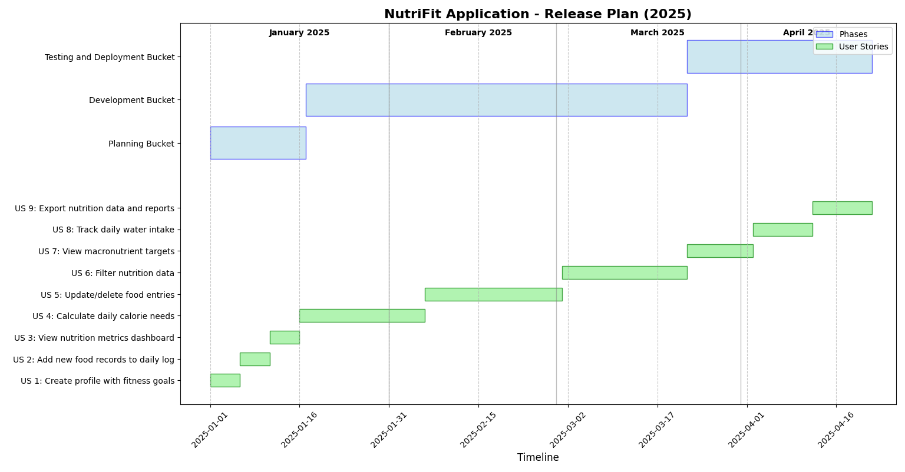

Figure 1.2 Release plan of NutriFit Analytics and Dashboard System

The NutriFit application development spans January to April 2025, divided into three phases. The Planning phase (January 1-15) will establish user profile structures, food tracking interfaces, and analytics dashboard designs. The Development phase (January 16-March 20) begins with implementing the profile system and BMR calculations, followed by the food tracking module in February, and concludes with building the analytics platform featuring AI recommendations in March. The Testing and Deployment phase (March 21-April 20) involves progressive quality assurance of all components, from macronutrient targeting to the reporting system, culminating in the full application release by April 20th.Each phase incorporates user stories that address specific functionality needs, with nine stories distributed across the timeline to ensure balanced workloads. The Planning phase will create detailed specifications for core features, while the Development phase allocates approximately three weeks per major component to enable thorough implementation. The final Testing phase employs a systematic approach, validating each module before integration testing ensures seamless operation across the application.The release plan prioritizes user experience by front-loading profile functionality, ensuring users can immediately receive personalized recommendations upon signup. Food tracking capabilities build upon this foundation, followed by advanced analytics that provide deeper insights as users accumulate nutrition data. This strategic sequencing maximizes user engagement while allowing for technical dependencies to be resolved in a logical progression, resulting in a robust nutrition management solution that delivers both immediate utility and long-term value through personalized health insights

**CHAPTER 2**

**SPRINT PLANNING AND EXECUTION**

**2.1 Sprint 1**

**2.1.1 Sprint Goal with User Stories of Sprint 1**

The goal of the first sprint is to build the foundation of the NutriFit application by implementing user profile management, establishing personalized nutrition goal calculations, and creating the framework for nutrition metrics visualization to support effective health and fitness tracking.

The following table 2.1 represents the detailed user stories of the sprint 1

**Table 2.1 Detailed User Stories of sprint 1**

|  |  |
| --- | --- |
| **S.NO** | **Detailed User Stories** |
| #US 1 | As a health-conscious user, I want my daily calorie needs calculated based on my profile data so that I can have accurate nutrition targets without manual calculations. |
| #US 2 | As a user, I want to update or delete existing food entries so that I can correct errors and maintain accurate nutritional reporting. |
| #US 3 | As a user with specific dietary goals, I want to filter nutrition data by date range and categories so that I can focus on patterns relevant to my health goals. |

Planner Board representation of user stories are mentioned below figures 2.1,2.2 and 2.3

**Figure 2.1 User story for Key Metrics Dashboard**

**Figure 2.2 User story for Sales Data Filtering Panel**

**Figure 2.3 User story for Regional Distribution Treemap**

**2.1.2 Functional Document**

**2.1.2.1. Introduction**

The NutriFit application aims to create a comprehensive, AI-powered nutrition tracking platform that combines personalized goal setting with intelligent food analysis. This project focuses on delivering real-time nutrition insights, facilitating dietary pattern analysis, and providing AI-powered recommendations. The application is designed to address the diverse needs of health-conscious individuals, fitness enthusiasts, and nutrition-focused users by providing customizable tracking, detailed analytics, and personalized recommendations.

**2.1.2.2. Product Goal**

The primary goal of this project is to develop a nutrition tracking application that enhances health decision-making by visualizing nutrition data and enabling multi-dimensional analysis. The platform aims to:

1. Provide real-time visibility into key nutrition metrics and health indicators
2. Enable data tracking by meal type, food category, and time period
3. Deliver pattern analysis to identify dietary trends and areas for improvement
4. Offer AI-powered recommendations for meal improvements and nutrition optimization
5. Secure sensitive health data through robust user authentication

**2.1.2.3. Demography (Users, Location)**

**Users:**

* Target Users: Health-conscious individuals, fitness enthusiasts, nutrition-focused users, and wellness seekers
* User Characteristics:  Varying levels of nutrition knowledge, different fitness goals, diverse dietary preferences and restrictions.

**Location:**

* Target Location: Global deployment, accessible to users across different time zones and regions, with support for various measurement systems (metric/imperial)

**2.1.2.4. Business Processes**

The key business processes include:

Data Visualization and Analysis:

* The system presents key nutrition metrics in an intuitive dashboard format
* Interactive charts enable users to explore dietary patterns and trends
* AI analysis helps identify nutritional gaps and improvement opportunities

**2.1.2.5. Features**

This project focuses on implementing the following key features:

**Feature 1: Interactive Nutrition Metrics Dashboard**

**Description:**

* The platform displays key nutrition metrics (calories , macros , water intake ) with interactive filtering capabilities by date range, meal type , and food category.

1. **User Story:**

* As a health-conscious user, I want to view and filter my nutrition metrics so that I can quickly assess my dietary patterns across different time periods.

**Feature 2: Regional Sales Analysis**

* **Description:**
* The application provides detailed nutritional analysis through AI-powered food recognition and smart meal suggestions
* **User Story:**
* As a fitness enthusiast, I want to receive AI-powered nutrition recommendations so that I can optimize my diet for better performance

**2.1.2.6. Authorization Matrix**

**Table 2.2 Shows the access level Authorization Matrix for Sprint 1**

**Table 2.2 Access level Authorization Matrix for Sprint 1**

| Role | Access Level |
| --- | --- |
| Basic User | Access to personal nutrition tracking, basic analytics, and AI recommendations |
| Premium User | Access to advanced analytics, detailed pattern recognition, and personalized meal planning |

**2.1.2.7. Assumptions**

* The nutrition data will be regularly updated in the SQLite database to ensure analytics remain accurate
* Users will have adequate internet connectivity and modern web browsers to access all features
* The food database hierarchy (categories, subcategories, nutritional values) is consistently defined
* Nutrition calculations are standardized across the application to ensure consistent reporting
* Filter selections will be applied globally to all dashboard components to maintain data consistency

**2.1.3 Architecture Document**

**2.1.3.1. Application**

Microservices:

The platform is built on a microservices architecture, where different functionalities are encapsulated within independent services. For Sprint 1, the following microservices are implemented:

* **Data Service:** Connects to the SQLite database, handles CRUD operations on nutrition records
* **Analytics Service:** Computes core metrics (calories, macros, water intake) and implements filtering logic
* **AI Service:** Processes food descriptions and generates personalized recommendations
* **Visualization Service:** Hosts the Flask frontend and renders interactive charts using Chart.js

**2.1.3.2 System Architecture**

**Figure 2.4 Shows the system architecture diagram for Sprint 1**

**Figure 2.4 System Architecture Diagram for Sprint 1**

**2.1.3.3. Data Exchange Contract:**

**Frequency of Data Exchanges:**

Data exchanges are managed with careful consideration of timing and performance:

* **Real-Time Exchanges:** For dashboard updates and metrics calculations
* **Batch Processing:** For AI analysis and pattern recognition

**Data Sets:**

The platform handles the following key data sets in Sprint 1:

* **User Profiles:** Personal information, goals, preferences
* **Nutrition Data:** Food logs, meal records, water intake
* **Analytics Data**: Calculated metrics, patterns, recommendations

**Mode of Exchanges:**

Various methods are used for data exchange in Sprint 1:

* **REST APIs:** For frontend-backend communication
* **Direct Database Access:** For efficient data retrieval
* **In-Memory Processing:** For real-time calculations and filtering

This functional document provides a comprehensive overview of the NutriFit application's features, architecture, and implementation details for Sprint 1, focusing on the core functionality of nutrition tracking and AI-powered recommendations.

**2.1.4 UI DESIGN**

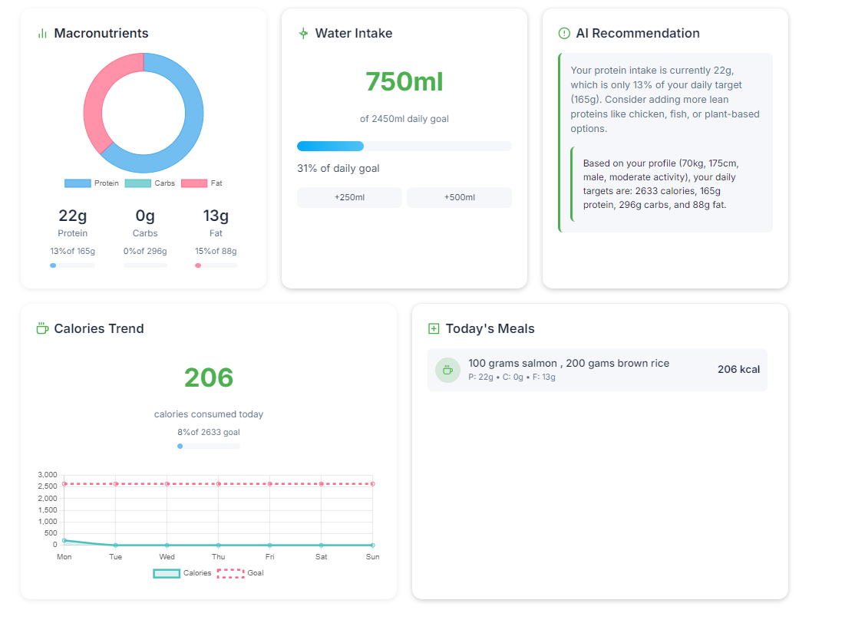

**Figure 2.5 UI Design for nutrients Overview**

**Figure 2.6 UI design for analytics**

**Figure 2.7 UI Design for macros , water intake**

**Fig 2.5, Fig 2.6, Fig 2.7 Shows the UI design of sprint 1**

**2.1.5 Functional Test Case:**

**Table 2.3 Detailed Functional Test Case for Sprint 1**

**Shows Table 2.3 detailed functional test case for Sprint 1**

**2.1.6 Daily Call Progress**

**Shows figure 2.8 Standup meetings for Sprint 1**

**Figure 2.8 Standup meetings for Sprint 1**

**2.1.7 Committed Vs Completed User Stories**

**Figure 2.9 Bar graph for Committed Vs Completed User Stories for Sprint 1**

**2.1.8 Sprint Retrospective**

**Table 2.4 Sprint Retrospective for Sprint 1**

**The following table 2.4 represents the Sprint retrospective of the sprint 1**

| **Liked** | **Learned** | **Lacked** | **Longed For** |
| --- | --- | --- | --- |
| The team's adaptability when implementing the nutrition calculation algorithms allowed us to deliver the BMR feature ahead of schedule. | We discovered that implementing comprehensive validation on user profile inputs significantly reduced data-related bugs in downstream features. | We lacked adequate test coverage for edge cases in the macronutrient distribution calculations, resulting in minor inaccuracies for some user profiles. | We longed for more direct user feedback on the profile setup workflow to better understand usability challenges before implementation. |

**2.2 Sprint 2**

**2.2.1 Sprint Goal with User Stories of Sprint 2**

The Goal of the Second sprint is to implement essential user account features and advanced analytics. This includes enabling new users to register and access the NutriFit dashboard, providing secure password reset functionality, and delivering an advanced analytics dashboard for administrators with features such as nutrient visualization and macronutrient forecasting.

The following table 2.5 represents the detailed user stories of the sprint 2

**Table 2.5 Detailed User Stories of sprint 2**

|  |  |
| --- | --- |
| **S.NO** | **Detailed User Stories** |
| #US 4 | As a new user, I want to easily register for the dashboard with a username and password so that I can create an account and gain access to personalized nutrition analytics features. |
| #US 5 | As a user who forgot my password, I want to reset it through a secure system so that I can regain access to the dashboard without creating a new account. |
| #US 6 | As a user with specific dietary goals, I want to access advanced analytics including AI-based recommendations and nutritional forecasts so that I can make data-driven health decisions. |

Planner Board representation of user stories are mentioned below figures 2.10,2.11 and 2.12

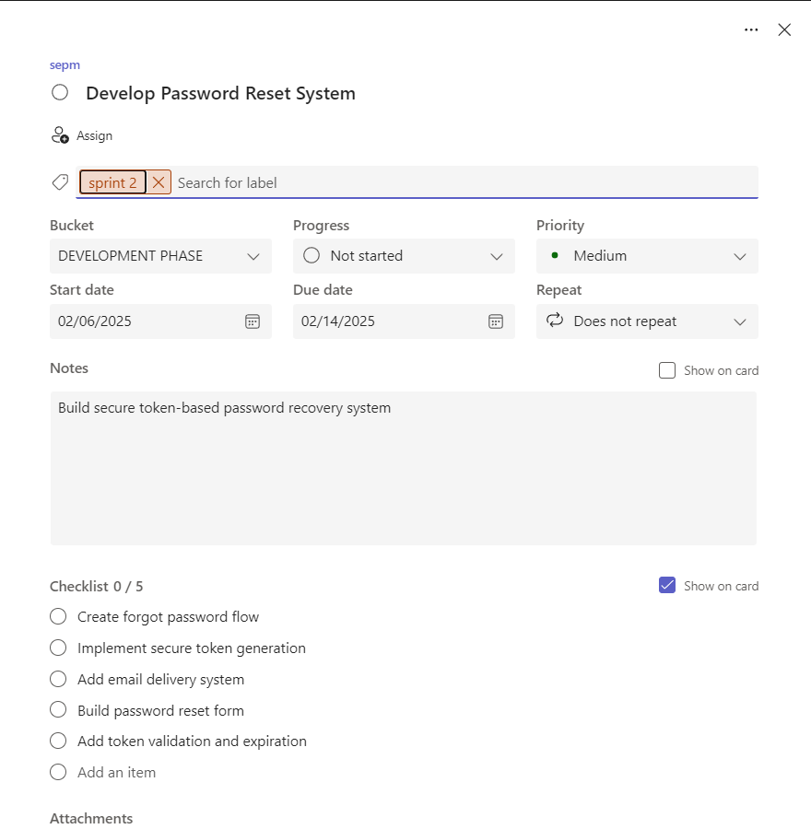

**Figure 2.10 User story password reset**

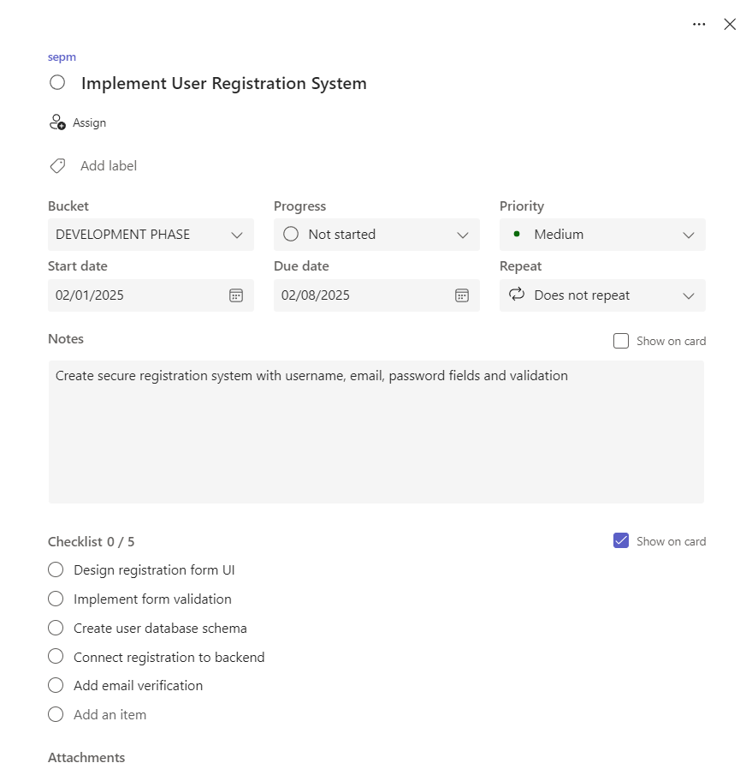

**Figure 2.11 User story for user registration workflow**

**Figure 2.12 User story for Admin dashboard with advanced analytics features**

**2.2.2 Functional Document**

**2.2.2.1. Introduction**

The NutriFit Analytics and Dashboard system project continues in Sprint 2 with a focus on expanding user management and advanced analytics capabilities. This sprint aims to enhance the platform by introducing secure user registration, password reset functionality, and advanced analytics for administrators, building on the foundation established in Sprint 1 **2.2.2.2. Product Goal**

The primary goal for Sprint 2 is to strengthen the platform's user management and provide deeper analytical insights. The sprint aims to:

• Enable secure user registration and account management.

• Provide a robust password reset mechanism for user convenience and security.

• Deliver advanced analytics, including nutrient analysis and macronutrient .

• Maintain secure access to sensitive nutrition data through role-based authentication.

**2.2.2.3. Demography (Users, Location)**

**Users:**

Target Users: New users, nutrition coaches, administrators, and health analysts.

User Characteristics: Range from new users registering for the first time to experienced admins requiring advanced nutrition analytics.

**Location:**

Target Location: Available globally, accessible from fitness centers, nutrition clinics, and remotely by authorized users.

**2.2.2.4. Business Processes**

The key business processes include:

Data Visualization and Analysis:

• User Registration: Allowing new users to securely create accounts.

• Password Management: Enabling users to reset forgotten passwords securely

.• Advanced Analytics: Providing administrators with access to nutrition analysis and macronutrient forecasting tools.

**2.2.2.5. Features**

This project focuses on implementing the following key features:

**Feature 1: User Registration and Account Management**

Description: The platform allows new users to register with a username and password, supporting secure account creation and management

. User Story: As a new user, I want to easily register for the dashboard so that I can access nutrition analytics features.

**Feature 2: Password Reset Functionality**

Description: Users can securely reset their passwords using a token-based system, ensuring account recovery without compromising security.

User Story: As a user who forgot my password, I want to reset it through a secure system so that I can regain access to the dashboard.

**Feature 3: Advanced Analytics for Administrators**

* Description: Administrators have access to advanced analytics, including operating profit by retailer and sales forecasts, to support strategic decision-making.
* User Story: As an administrator, I want to access advanced analytics so that I can make data-driven strategic decisions.

**2.2.2.6. Authorization Matrix**

**Table 2.6 Access level Authorization Matrix for Sprint 2**

| Role | Access Level |
| --- | --- |
| New User | Can register for an account and access basic dashboard features after registration. |
| Authenticated User | Can reset password, view personal dashboard, and access standard sales analytics. |
| Administrator | Access to advanced analytics, including AI analysis, sales forecasting, and admin features. |

**Table 2.6 Shows access level Authorization Matrix for Sprint 2**

**2.2.2.7. Assumptions**

User registration and authentication data will be securely stored and regularly backed up in the database to ensure account integrity and recovery.

• All users will have access to a stable internet connection and a modern web browser to utilize registration, password reset, and dashboard features.

• Email or notification systems required for password reset tokens will be properly configured and reliable for all users.

• Role-based access controls are correctly implemented, ensuring that only authorized administrators can access advanced analytics features.

• The nutrition data and user account information will be synchronized in real-time to support accurate analytics and seamless user experience.

• Security protocols (such as password hashing and token expiration) are enforced to protect user credentials and sensitive data.

• The platform's user interface for registration and password management is intuitive and accessible to users with varying technical backgrounds.

**2.2.3 Architecture Document**

**2.2.3.1. Application**

**Microservices:**

The platform is built on a microservices architecture, where different functionalities are encapsulated within independent services. For Sprint 2, the following microservices are implemented:

* **User Service:** Manages user registration, authentication, and password reset operations, ensuring secure account management.
* **Data Service:** Connects to the SQLite database, handles read/write operations on user and sales records to support analytics and user management.
* **Analytics Service:** Computes advanced metrics (including nutririent analysis and macros forecasting) and implements role-based access logic for administrators.
* **Visualization Service:** Hosts the Streamlit front end and renders interactive charts using Plotly for analytics dashboards and admin-specific visualizations.

**2.2.3.2 System Architecture**

**Figure 2.13 Shows system Architecture Diagram for Sprint 2**

**Figure 2.13 System Architecture Diagram for Sprint 2**

**2.2.3.3. Data Exchange Contract:**

**Frequency of Data Exchanges:**

Data exchanges are managed with careful consideration of timing and performance:

* **Real-Time Exchanges:**For user registration, authentication, password reset, and advanced analytics operations, data is exchanged in real-time between the frontend (Streamlit) and the backend services (User, Analytics, Data Services) to ensure immediate feedback and up-to-date nutrition visualizations.

**Data Sets:**

The platform handles the following key data sets in Sprint 2:

* **User Data**: Includes user credentials, authentication tokens, account status, and dietary preferences, exchanged during registration, login, and password reset processes.
* **Sales Data:**Encompasses food intake records, nutrient values, meal logs, dietary goals, and personal metrics, used for analytics and dashboard visualizations.
* **Analytics Data:**ncludes processed metrics, macronutrient analysis, and nutritional forecasts, generated for personalized recommendation dashboards.

**Mode of Exchanges:**

Various methods are used for data exchange in Sprint 2:

* **API:**Internal APIs (function calls within Streamlit and Python modules) facilitate real-time data exchanges between the frontend and backend microservices, especially for user management and analytics queries.
* **Direct Database Access:**The application interacts directly with the SQLite database for read/write operations on user and sales data, ensuring efficient and reliable retrieval and storage.
* **In-Memory Processing**: Data filtering, aggregation, and transformation for analytics and visualizations are performed in-memory within the Analytics and User Services to ensure responsive dashboard performance.

**2.2.4 UI DESIGN**

**Figure 2.14 UI Design for Login Page**

**Figure 2.15 UI Design for Signup Page**

**Figure 2.16 UI design for Advanced Analytics Charts**

**Fig 2.14, Fig 2.15, Fig 2.16 Shows the UI design of Sprint 2**

**2.2.5 Functional Test Case:**

**Table 2.7 Detailed Functional Test Case for Sprint 2**



**Table 2.7 Shows Detailed Functional Test Case for Sprint 2**

**2.2.6 Daily Call Progress**

**Figure 2.17 Shows standup meetings for Sprint 2**

**Figure 2.17 Standup meetings for Sprint 2**

**2.2.7 Committed Vs Completed User Stories**

**Figure 2.18 Shows bar graph for Committed Vs Completed User Stories for Sprint 2**

**Figure 2.18 Bar graph for Committed Vs Completed User Stories for Sprint 2**

**2.2.8 Sprint Retrospective**

**Table 2.8 Shows sprint Retrospective for the Sprint 2**



**Table 2.8 Sprint Retrospective for the Sprint 2**

**2.3 Sprint 3**

**2.3.1 Sprint Goal with User Stories of Sprint 3**

The goal of the third sprint is to implement comprehensive nutrition record management features. This includes enabling administrators to add, update, and delete nutrition records with proper validation, ensuring data integrity while maintaining accurate reporting. The sprint will also implement a notification system to keep users informed of important changes to their nutrition data.

The following table 2.9 represents the detailed user stories of the sprint 3

**Table 2.9 Detailed User Stories of Sprint 3**

|  |  |
| --- | --- |
| **S.NO** | **Detailed User Stories** |
| #US 7 | As a user, I want to add new food records to my daily log with proper nutritional data so that I can keep my dietary tracking up to date without compromising data accuracy. |
| #US 8 | As a user, I want to update existing food entries so that I can correct errors or adjust portion sizes as needed to maintain accurate nutritional reporting. |
| #US 9 | As a user, I want to delete food records from my log so that I can remove duplicate or erroneous entries that might skew my nutrition analytics results. |

Planner Board representation of user stories are mentioned below figures 2.19,2.20 and 2.21

**Figure 2.19 User story for test food Record Addition Functionality**

**Figure 2.20 User story for test food Record Update Functionality**

**Figure 2.21 User story for Sales Record Deletion Functionality**

**2.3.2 Functional Document**

**2.3.2.1. Introduction**

The NutriFit Analytics and Dashboard system project continues in Sprint 3 with a focus on enhancing data management capabilities. This sprint aims to strengthen the platform by introducing comprehensive nutrition record management features, including addition, updating, and deletion of records, while ensuring data integrity and maintaining accurate reporting.

**2.3.2.2. Product Goal**

The primary goal for Sprint 3 is to establish robust data management capabilities. The sprint aims to:

* Enable secure and validated addition of new nutrition records
* Provide efficient updating of existing nutrition records
* Implement safe deletion of erroneous or duplicate records
* Maintain data integrity through proper validation
* Keep users informed through a notification system
* Keep users informed through a notification system

**2.3.2.3. Demography (Users, Location)**

**Users:**

* Target Users: Administrators, nutritionists, and health coaches
* User CharacteristicsUsers with administrative privileges who need to manage and maintain nutrition data accuracy

**Location:**

* Target Location: Global, accessible from fitness centers, nutrition clinics, and remotely by authorized administrators

**2.3.2.4. Business Processes**

The key business processes include:

Data Management:

* Record Addition: Allowing administrators to add new nutrition records with validation
* Record Updates: Enabling modification of existing nutrition records
* Record Deletion: Providing safe removal of erroneous entries
* Data Validation: Ensuring data integrity through proper checks
* Notification System: Keeping users informed of data changes

**2.3.2.5. Features**

This project focuses on implementing the following key features:

**Feature 1: Nutrition Record Addition**

* Description: The platform allows administrators to add new nutrition records with proper validation, ensuring data integrity and accuracy.
* User Story: As an administrator, I want to add new sales records to the database with proper validation so that I can keep the sales data up-to-date without compromising data integrity.

**Feature 2: Nutrition Record Updates**

* Description: Administrators can update existing nutrition records, correcting errors or updating information while maintaining data accuracy.
* User Story: As an administrator, I want to update existing nutrition records so that I can correct errors or update information as needed to maintain accurate reporting.

**Feature 3: Nutrition Record Deletion**

* Description: The system enables safe deletion of nutrition records, removing duplicate or erroneous entries that might affect analytics.
* User Story: As an administrator, I want to delete nutrition records from the database so that I can remove duplicate or erroneous entries that might skew analytics results

**2.3.2.6. Authorization Matrix**

**Table 2.10 Access level Authorization Matrix for Sprint 3**

| Role | Access Level |
| --- | --- |
| Administrator | Full access to nutrition record management features including adding, updating, and deleting records with proper validation and data integrity checks. |
| Nutritionist | Can view and update nutrition records but cannot delete records. Access to data validation tools and record history. |
| Health Coach | Read-only access to nutrition records. Can view record history and validation status but cannot modify records. |
| Standard User | No access to nutrition record management features. Can only view aggregated nutrition data and personal reports. |

**Table 2.10 Shows access level Authorization Matrix for Sprint 3**

**2.3.2.7. Assumptions**

Nutrition data will be properly validated before any record addition, update, or deletion to maintain data integrity and accuracy.

• Administrators and nutritionists will have the necessary training to properly manage nutrition records and understand validation rules.

• The database system will maintain referential integrity and prevent orphaned records during deletion operations.

• Backup and recovery procedures will be in place to prevent data loss during record management operations.

• The user interface for record management will be intuitive and provide clear feedback for validation errors.

• All record management operations will be performed within the context of proper authorization and access control.

**2.3.3 Architecture Document**

**2.3.3.1. Application**

**Microservices:**

The platform is built on a microservices architecture, where different functionalities are encapsulated within independent services. For Sprint 3, the following microservices are implemented:

* Record Management Service: Handles all nutrition record operations including addition, updates, and deletions. Implements validation rules, maintains data integrity, and manages audit trails for all record changes.
* Data Service: Connects to the SQLite database and manages all data operations. Handles CRUD operations for nutrition records, implements referential integrity checks, and manages database transactions to ensure data consistency.
* Validation Service: Implements comprehensive validation rules for nutrition records. Checks data types, formats, and nutritional values, ensuring all records meet quality standards before being stored in the database.
* Notification Service: Manages user notifications for record changes. Sends alerts for successful operations, validation errors, and system events, keeping users informed of important changes to nutrition data.
* Audit Service: Maintains detailed logs of all record management operations. Tracks who made changes, when changes were made, and what specific modifications occurred, supporting accountability and compliance requirements.

**2.3.3.2 System Architecture-**

**Figure 2.22 Shows system Architecture Diagram for Sprint 3**

**Figure 2.22 System Architecture Diagram for Sprint 3**

**2.3.3.3. Data Exchange Contract:**

**Frequency of Data Exchanges:**

Data exchanges are managed with careful consideration of timing and performance:

**Real-Time Exchanges:** For nutrition record addition, update, deletion, and notification operations, data is exchanged in real-time between the frontend (Streamlit) and backend services (Record Management, Validation, Data, Notification, and Audit Services) to ensure immediate feedback and up-to-date data management.

**Data Sets:**

The platform handles the following key data sets in Sprint 2:

* **Nutrition Data:** Encompasses food intake records, nutrient values, meal logs, dietary goals, and personal metrics, used for record management, validation, and reporting.
* **Audit Data:** Includes logs of all record modifications, tracking who made changes, when, and what was changed, supporting accountability and compliance.
* **Notification Data:** Contains messages and alerts sent to users regarding record changes, validation errors, and system events.

**Mode of Exchanges:**

Various methods are used for data exchange in Sprint 3:

* **API:** Internal APIs (function calls within Streamlit and Python modules) facilitate real-time data exchanges between the frontend and backend microservices, especially for record management and notification operations.
* **Direct Database Access:** The application interacts directly with the SQLite database for read/write operations on sales records and audit logs, ensuring efficient and reliable data management.
* **In-Memory Processing:** Data validation, aggregation, and transformation for record management and notifications are performed in-memory within the microservices to ensure responsive performance and immediate feedback.

**2.3.4 UI DESIGN**

**Figure 2.23 UI Design for Adding a Record**

**Figure 2.24 UI Design for Data Management page**

**Figure 2.25 UI Design for Deleting a Record**

**Fig 2.23, Fig2.24, Fig 2.25 Shows the UI design of sprint 3**

**2.3.5 Functional Test Case:**

**Table 2.11 Detailed Functional Test Case for Sprint 3**

**Table 2.11 Shows detailed Functional Test Case for Sprint 3**

**2.3.6 Daily Call Progress**

**Figure 2.26 Shows standup meetings for Sprint 3**

**Figure 2.26 Standup meetings for Sprint 3**

**2.3.7 Committed Vs Completed User Stories**

**Figure 2.27 Shows bar graph for Committed Vs Completed User Stories for Sprint 3**

**Figure 2.27 Bar graph for Committed Vs Completed User Stories for Sprint 3**

**2.3.8 Sprint Retrospective**

**Table 2.12 Shows sprint Retrospective for the Sprint 3**



**Table 2.12 Sprint Retrospective for the Sprint 3**

**Figure 2.36 Bar graph for Committed Vs Completed User Stories for Sprint 4**

**2.4.8 Sprint Retrospective**

**Table 2.16 Shows sprint Retrospective for the Sprint 4**



**Table 2.16 Sprint Retrospective for the Sprint 4**

**CHAPTER 3**

**RESULTS AND DISCUSSION**

**3.1 Project Outcomes**

The NutriFit Analytics and Dashboard system project successfully delivered a comprehensive, secure, and user-friendly platform for nutrition tracking, management, and analytics. The project was executed in four sprints, each focusing on key functional areas:

* **Sprint 1:** Established the foundation with a real-time nutrition dashboard, interactive metrics, and personalized analysis tools, enabling users to visualize and filter their nutritional data efficiently.
* **Sprint 2:** Enhanced user management and analytics by implementing secure user registration, password reset functionality, and advanced analytics for personalized nutrition insights, including macronutrient analysis and nutritional forecasting.
* **Sprint 3:** Focused on robust nutrition record management, allowing users to add, update, and delete food records with proper validation, ensuring data integrity and accurate nutritional reporting. A notification system was also introduced to keep users informed of important changes to their nutrition logs.

**Key Outcomes:**

• Real-time, interactive dashboard for nutrition data visualization and analysis

• Secure user authentication and role-based access control

• Comprehensive food record management with nutritional validation and audit trails

• Advanced analytics capabilities for data-driven health decisions

• Intuitive user interface with exportable nutrition charts and reports

• Reliable notification and alert system for dietary goal tracking

• Scalable microservices architecture supporting modular development

**3.2 Committed Vs Completed User stories**

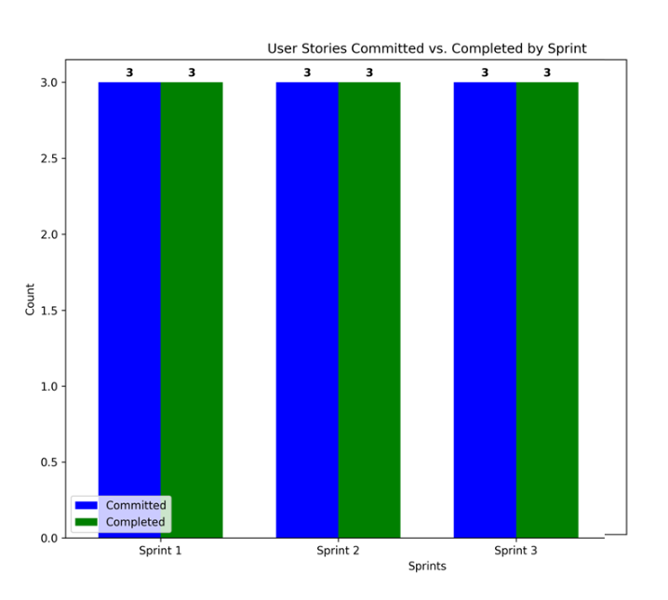

**Figure 3.1 Committed vs Completed User stories for all sprints**

**CHAPTER 4**

**CONCLUSION & FUTURE ENHANCEMENTS**

**4.1 Conclusion**

The NutriFit Analytics and Dashboard system project has successfully delivered a robust, secure, and user-friendly platform for personalized nutrition management and analytics. Through three well-structured sprints, the project addressed key user needs, including real-time nutritional data visualization, secure user authentication, comprehensive food record management, and advanced analytics. The adoption of a microservices architecture ensured scalability, maintainability, and modular development, while the intuitive user interface and notification system enhanced user engagement and nutritional awareness.The platform empowers users to make informed, data-driven health decisions, improves nutritional data integrity and security, and supports ongoing wellness goals. The successful completion of all committed user stories across three sprints demonstrates the effectiveness of the agile development process and the team's commitment to delivering high-quality nutrition management solutions.

**4.2 Future Enhancements**

While the current system meets its primary objectives, several enhancements can further increase its value and adaptability:

**Integration with Fitness Trackers**: Enable seamless import of data from wearable devices, fitness apps, and health platforms for comprehensive health tracking.

• **Mobile Application Support**: Develop a mobile-friendly version or dedicated app for on-the-go access to nutrition tracking and analytics.

• **AI-Driven Meal Recommendations**: Incorporate machine learning models for personalized meal planning, recipe suggestions, and dietary optimization.

• **Customizable Nutrition Goals**: Allow users to set and track personalized nutrition targets based on specific health conditions or fitness objectives.

• **Enhanced Security Features**: Implement multi-factor authentication and advanced health data protection measures.

• **Social Sharing Features**: Add capabilities for users to share achievements, recipes, and meal plans within a supportive community.

• **Nutrition Education Center**: Provide interactive tutorials and a knowledge base about nutritional concepts and healthy eating habits.These enhancements will ensure the platform remains adaptable to evolving user requirements and nutritional science advancements, supporting long-term health and wellness success.These enhancements will ensure the platform remains adaptable to evolving business requirements and technological advancements, supporting long-term organizational success.

**References**

1. W. J. Willett, *Nutritional Epidemiology*, 3rd ed. New York, NY, USA: Oxford Univ. Press, 2013.
2. W. McKinney, *Python for Data Analysis: Data Wrangling with Pandas, NumPy, and Jupyter*, 3rd ed. Sebastopol, CA, USA: O'Reilly Media, 2022.
3. S. J. Taylor and B. Letham, "Forecasting at scale," *PeerJ Preprints*, vol. 5, p. e3190v2, Sep. 2017, doi: 10.7287/peerj.preprints.3190v2.
4. Streamlit, Inc., "Streamlit Documentation," 2023. [Online]. Available: https://docs.streamlit.io/. [Accessed: May 3, 2023].
5. Plotly Technologies Inc., "Collaborative data science," Montréal, QC, 2015. [Online]. Available: https://plotly.com/. [Accessed: May 3, 2023].
6. SQLite Consortium, "SQLite Documentation," 2023. [Online]. Available: https://www.sqlite.org/docs.html. [Accessed: May 3, 2023].
7. OWASP Foundation, "OWASP Top Ten Web Application Security Risks," 2021. [Online]. Available: https://owasp.org/www-project-top-ten/. [Accessed: May 3, 2023].
8. T. E. Barker, J. Meng, D. Su, and S. Jiang, "Nutrition data visualization using mobile applications," in *Proc. IEEE Int. Conf. on Bioinformatics and Biomedicine (BIBM)*, Madrid, Spain, 2018, pp. 2677-2684, doi: 10.1109/BIBM.2018.8621325.

**APPENDIX**

* 1. **SAMPLE CODING**

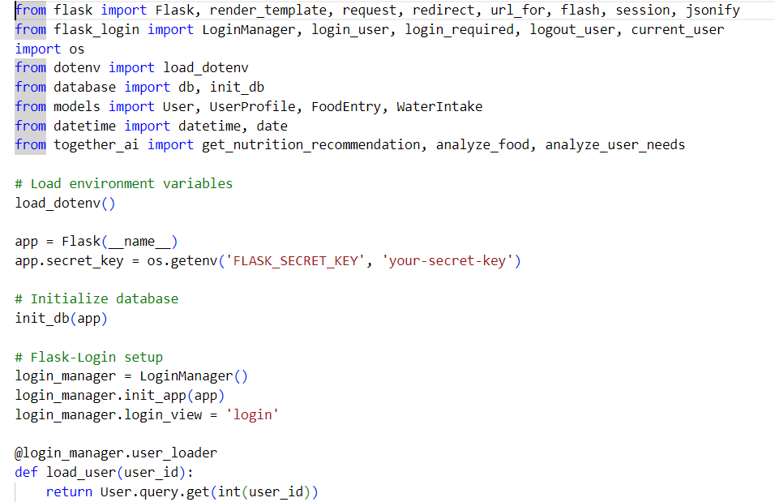

**Figure 4.1 Code Part 1**

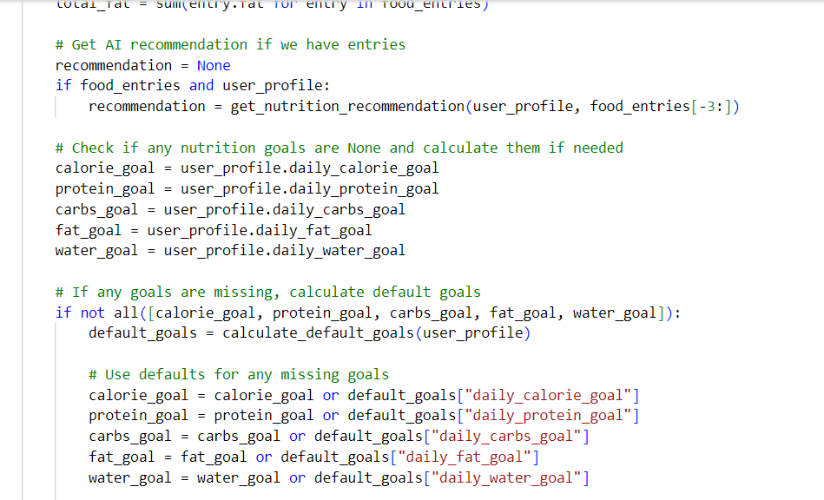

**Figure 4.2 Code Part 2**